**UTILIZING DIFFERENT ANALYSING TECHNIQUES SUPPLEMENTED WITH OPERATIONS RELATED THEORY TO RECOMMEND FUTURE DECISION MAKING FOR THE CLIENT COMPANY.**

**Author – Deeksha Deepak**

Table of Contents

1.INTRODUCTION 5

2.MARKET ANALYSIS 5

3.DATA STRUCTURING AND CLEANING 6

4.DESCRIPTIVE STATISTICS 6

4.1 THE COMPANY'S CURRENT SITUATION: 6

4.2 PRODUCT FAMILY PROFILE 9

4.2.1 Self-watering planters 9

4.2.2 BINS 11

4.4.3 PLANTERWARE 13

5. FORECASTIC ANALYSIS 14

5.1 PREDICTIVE PRODUCT FORECUT 14

5.2 DEMAND FORECASTING 16

6.PORTFOLIO ANALYSIS 17

6.1 CURRENT BUSINESS MODEL 17

6.2 CURRENT SUPPLY CHAIN MODEL 18

7. OPERATIONS MANAGEMENT 19

7.1 MARKETING 19

7.2 SUPPLY CHAIN 19

8. CONCLUSION AND RECCOMENDATIONS 23

9 .REFERENCES: 25

10. APPENDIX: 27

TABLE OF FIGURES

Figure 1: Plastic segment dominated the global flower pots and planters market in 2020 6

Figure 2: Count of products produced by the company. 8

Figure 3: Sales by product family 9

Figure 4: Sales of bins, planter-ware, and self-watering 2006-2012 9

Figure 5:Profit earned from 2006-2012 9

Figure 6: SELF-WATERING PLANTERS BY COLOURS 10

Figure 7:Color use by powder weight for self-watering products 11

Figure 8: Total sales of self-watering planters 2006-2012 12

Figure 9: Total number of sales of bins from2006 to 2012 13

Figure 10: sales of bin:2006-2012 13

Figure 11: Total sales of planter-ware products during 2010-2012 (Unit) 14

Figure 12: Total sales of planter-ware products during 2010-2012 14

Figure 13: Product weight statistics 15

Figure 14 : Total sales of bins, planter ware and self-watering from2006 to 2012 16

Figure 15:Average percentage of due date performance. (2006-2012) 16

Figure 16: Sales Forecast of planter ware products 2013-2016 17

Figure 17: 4 years forecast of self-watering planters 2012-2016 of only special colours. 18

Figure 18: 4 Year sales forecast for standard colour self-watering - 2013 to 2016 18

Figure 19:4 Year sales forecast for BINS - 2013 to 2016 19

Figure 20: Fishers model used currently. 20

Figure 21: Current supply chain model 20

Figure 22: Typical demand performance through the years 21

Figure23: current fishers’ model of the company. 22

Figure 24: Suggested fishers model using both MTO and MTS 23

Figure 25: Current MTO supply chain method 23

Figure 26: Company's Supply chain model with the OPP for MTS method for Planter ware and Bins 24

Figure 27: Lean/ agile supply chain method 25

**EXECUTIVE SUMMARY**

The following report focuses on analysing the data of a company’s sales and profit that sells planter ware and bins from the year 2006-2012 for future managerial decisions and strategic planning. Descriptive analytics has been utilised and implemented to this data to find the company’s current economic and sales outcomes based on past data. Adding on predictive analytical methods have been implemented to forecast the company’s sales for the next four years. All of this is backed up by industry data and theoretical frameworks, resulting in comprehensive and evidence-based recommendations.

Similarly, as a UK-based garden goods merchant, the company's supply chain and operations management (OM) are tested each year by the unpredictability of the UK climate. Where the requirement distribution varies according to the seasons. As a result, the significance of business function alignment and a manufacturing plan that fulfils market demands is highlighted.

Finally, recommendations have been made for the company to consider implementing after analysing and visualising its past data , for better sales and operations to the company.

1.INTRODUCTION

The following report will cover data from a company case study to propose an informed solution on which to base future decision-making to improve current performance by ensuring that the correct alignment between product types and supply chains is met and implemented across all departments like the company's inventory planning, operations, sales decision making, supply chain management, logistics, and marketing strategies, ensuring the pursuit of a common goal: improving business performance. The company specializes in the production of garden essentials like planters and bins. The report comes with an MS Excel document to assist the manager in making sound decisions based on the recommendations and data analysis. In a linear regression model, these product qualities serve as independent variables. Fisher's model to determine the company's supply chain strategies has also been used. This study would use descriptive analytics and data mining to analyse the company's sales data in order to anticipate the impact of price/unit cost, sizes, and colours on sales performance.

# 2.MARKET ANALYSIS

In 2020, the global flowerpots and planters’ market was worth $978.70 million, with a forecast of $1.5 billion by 2030(Allied Market Research, n.d.). As the company produces a range of plastic bins research shows that the plastic sector contributed the most to the flowerpots and planters market size, with $328.1 million in 2020, and is expected to reach $479.6 million by 2030, according to the flowerpots and planters market trend (Allied Market Research, n.d.).

Figure 1: Plastic segment dominated the global flower pots and planters market in 2020

Nowadays, millennials are more interested in gardening and have created and placed little plant pots on their balconies and other locations. A crucial reason driving the self-watering planter and pot industry is millennials' increased interest in planting vegetables, flowers, and spices in various sized pots. (The, 2020).

Gardening equipment sales have surged over the last half-decade, with industrialised countries such as China, the United States, and Germany seeing strong revenue increases. Demand and sales are increasing as a result of technological advancements in the business (Persistence Market Research, 2022).

3.DATA STRUCTURING AND CLEANING

The companies that collect or purchase big data may also spend as much on maintaining the data's health and cleaning as they do on collecting it. Take into account issues arising from incorrect or missing values, duplicates, and typos. You should keep your data current so that your calculations remain valid, accurate, and reliable (Emese Felvegi et al., 2019).

The first step undertaken in cleaning the data was categorizing and finding the cost of individual powder weight by implementing VLOOKUP which helped to calculate the cost price for each product to get better clarity about the sales of products from 2006 to 2012. The spelling of the colour Guernsey Granite was changed to Guerney Granite and the colour Dark standstone was changed to dark sandstone. Sales, cost and profit for each year were also calculated for better clarity to take decisions in the future.

# 4.DESCRIPTIVE STATISTICS

## 4.1 THE COMPANY'S CURRENT SITUATION:

To get a better perspective of the sales of the product family’s different data mining techniques and descriptive statistical methods were used. This also helped in identifying trends and patterns in the data. The company has two product families’ planters and bins. The company has two kinds of planters namely self-watering and Planter-ware. There are 202 products manufactured by the company also offering various colours in each. (Refer to figure 2).

Figure 2: Count of products produced by the company.

After further analysis, we can see that the self-watering planter generate the most revenue for the company with about £2.3 million from 2006-to 2012. Plastic bins and self-watering pots accounted for around £1,48 million in sales between 2006 and 2009. According to figure 3, the sale of planter-ware and bins was relatively steady from 2006 through 2009 with the exception of a slight dip during 2009.  By 2012, the graph also shows an increase in sales of planter-ware from £44,702 to £251,217. Meanwhile, bin sales saw a boost of over £590,925 in 2010 but a dip to £389,870 in 2012. This rise in performance and sales can be explained by the introduction of new products in product families – planter-ware in 2010. Additionally, in 2011, the company introduced new colours for its self-watering planters.

Figure 3: Sales by product family

The Figure below shows the number of units sold under each product family helping the company to decide which product family to focus more on. Figure 4 also shows that from 2010 there was a rise in the sales of planters. All the product families also shows a dip in sales during 2009 which might have occurred due to the Great United Kingdom recession period that hit in 2008

Figure 4: Sales of bins, planter-ware, and self-watering 2006-2012

Figure 5:Profit earned from 2006-2012

As already analysed self-watering planters make the most sales which is directly proportional to generating most profit for the 6 years as well. Self-watering products have generated a profit of £6,065,797.20 (figure 5) of the total revenue generated by the company. Simultaneously bins generated a £1,481,527.20 having some effect on the firm’s income through the years. Lastly planter-ware generated a sale of £178,445.50 although very less it should be kept in mind that the product was only introduced in 2010.

Using the data provided the company's product families were analysed in-depth in order to obtain more understanding of the company's products and their influence on sales performance.

## PRODUCT FAMILY PROFILE

To get a better perspective on the company’s operations and sales , individual product analysis was conducted and visualized.

4.2.1 Self-watering planters:

Figure 6: SELF-WATERING PLANTERS BY COLOURS

There are 29 different designs and colours of the self-watering planter family, which is the company's most popular product. Items of this type were previously only available in Black, Standard green and granite pink (Standard colour). With the release of new colour options (Special colour) this year, the firm has expanded its sales potential, thus helping to maintain a successful sales year in 2011-2012. Figure 5 illustrates that standard colour item sales remained steady from 2006 to 2012, averaging roughly £1.2 million per year. As a result of the introduction of special colour items, the overall sales of this product family have increased, reaching almost £1.7 million in 2012.

Figure :Color use by powder weight for self-watering products

From the figure above we can see that the customer demand for black items reached its height of popularity in 2007-2009, following a period when standard green self-watering planters replaced black products as the most popular by selling up to 80 thousand kgs. Brown, gurney granite and pink granite are the most popular special colours. To meet client demand in 2011-2012, the firm utilized roughly 17 thousand kg of pink granite plastic powder, 19 thousand kg of guerney granite plastic powder, and 15 thousand pounds of brown plastic powder.

Figure 8: Total sales of self-watering planters 2006-2012

When an analysis of all the Self-watering products is conducted and compared, It is seen that the sale of Half basket up the pole, Cup and Saucer, and Cup and Saucer on pole have the highest number of sales. Looking at the graph (figure 6) it can be understood that a lot of the total sales of Self-watering planters were because of these products. Barrier basket liner also sells around 12,207 products from 2006-to 2012.

### 4.2.2 BINS

Bins have been a part of the product range from 2006-to 2012. When all the products under bins are compared the most profitable product for the company was the Olympian dual bin making a sale of 954 units in 2010 immediately after only selling 25 units in 2009.

Figure 9: Total number of sales of bins from2006 to 2012

West min bin, Olympic dual bin and West min liner seem to be doing the best amongst all other bins throughout with a sale of 2823, 1916 and 1858 units respectively as shown in figure 8. Although as seen in figures 2 and 3 the sales of bins are low during the time 2006-2012. This product family has contributed over £2.1 million towards the company’s earnings.

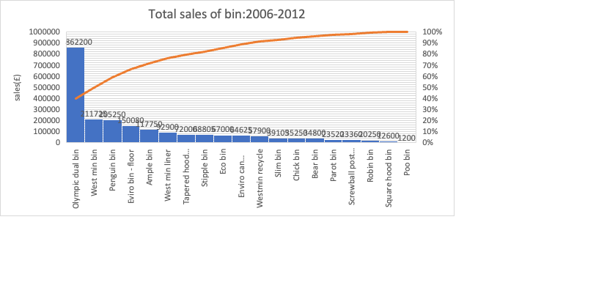

Figure 10: sales of bin:2006-2012

Figure 9 shows the maximum revenue earned was from the Olympic dual bin with total earnings of £8.6 million although it was only introduced in 2009. Bins with the lowest sales were all introduced towards the end of the sales record with poo bin being the least selling only 1200 of it.

### 4.4.3 PLANTERWARE

Figure 11: Total sales of planter-ware products during 2010-2012 (Unit)

Planter ware was introduced to the company in 2010 with about 10 individual products that affected the performance of the company positively. The most sold product from the planter ware family is the plain vase, selling about 2591 units (figure 11) and accounted for about 1.2 million pounds ( refer to figure 11) from 2010-2012 sales for the company. Adding on, rectangular container and egg pot vases also accounted for 67% of the total planter-ware sales.

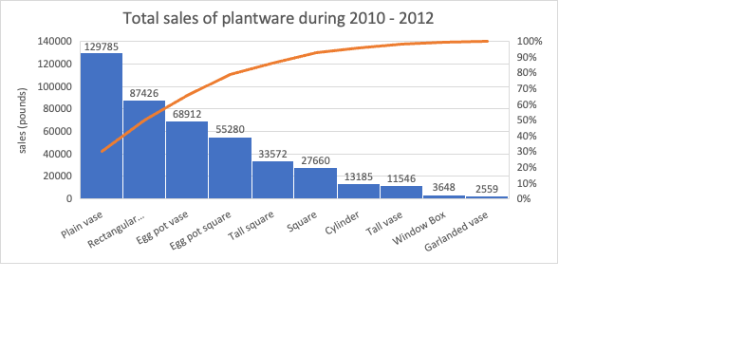

Figure 12: Total sales of planter-ware products during 2010-2012

Planter-ware being a new product family was introduced with new designs and colours.

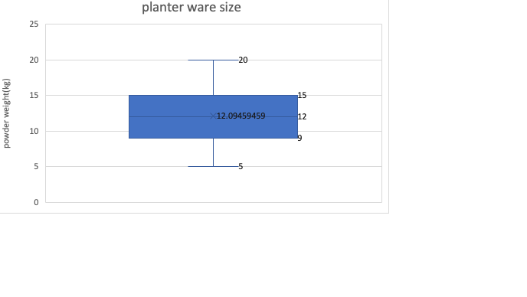

Figure 13: Product weight statistics

The boxplot (figure 13) shows that the company has an average of 12.09kg powder weight, it also shows that the company has a positive correlation which means that the higher the powder weight, the higher the product size.

The planter ware weight ranges from 5-20. As a rough estimate of the average favourable weight, a median is calculated to determine whether a weight is significant to the sales of the product. The powder weight of products within this family is not substantially different, with a median weight of 12 Kg, it is worthwhile to analyse this product characteristic and its influence on sales.

# 

# 5. FORECASTIC ANALYSIS

### 5.1 PREDICTIVE PRODUCT FORECUT

In predictive analytics, past and present facts are analysed to predict future or other unknown events using techniques like data mining, predictive modelling, and machine learning. (Wikipedia Contributors, 2022)

Figure 14 : Total sales of bins, planter ware and self-watering from2006 to 2012

The total number of units sold by the firm is shown in Figure 14. The linear graph also illustrates that the company incurred a loss from the years 2007 to 2010. The drop in sales might be attributable to the impact of the Great British recession, which began in 2008(Wikipedia Contributors, 2022). Further investigation reveals that sales climbed from 22470 to 29941 after 2010. The spike might be due to the company's decision to launch a new product line called Planter-ware. In 2011, the firm expanded its colour range. We may infer that the introduction of a new sector and colour has a significant impact on total sales.

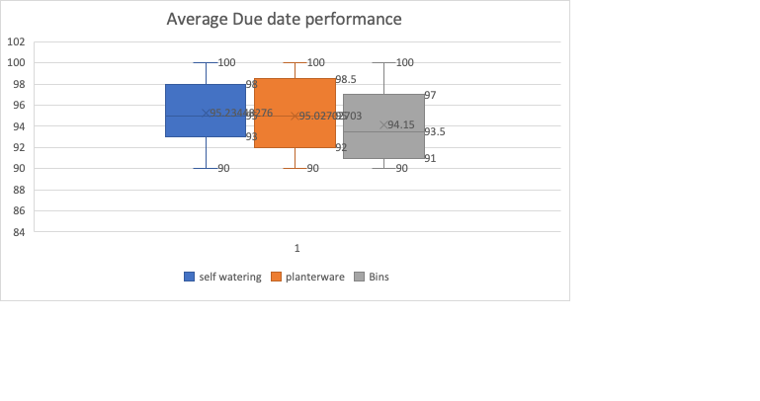

Figure 15:Average percentage of due date performance. (2006-2012)

Figure 15 shows that the company's average due date performance is about 95% when it comes to the delivery of the products sold to its customers. As the company follows an MTO business model, the company takes a good number of days to produce the order and delivered which may or may not be on time, therefore finding alternatives to improve due date performance could help the company from generating more sales than it already has.

### 5.2 DEMAND FORECASTING

Figure 16: Sales Forecast of planter ware products 2013-2016

The sales forecast was created using the exponential smoothing method, the X-axis is the sales year by its relationship with Y-axis is total sales. It appears that the sale of planter ware over the years has been rising drastically, according to the forecast in figure 16. It is also seen that in 2016, the sale of planter-ware could reach £659 thousand. Furthermore, we can find six distinct lower confidence levels in the forecast. In comparison with 2011, the average amount predicted to earn from 2012-to 2016 is £454620.

Figure 17: 4 years forecast of self-watering planters 2012-2016 of only special colours.

Forecasting self-watering planters using only the special colours showed that good sales are occurring and is predicted to continue over the years. The forecast increases over time. The lower confidence bound and upper confidence bound seems to be highly correlated. Figure 17 shows an increase in sales of self-watering planters in special colours from 2012-to 2016. There is a significant increase in the performance of sales each year almost making a turnover of 11.1 million pounds by 2016. The introduction of these new colours and products has helped in the production of the company’s revenue although this could be an issue for the company’s supply chain management. The increase in market demand for the products would push a strain on the capacity resources of the company’s supply chain, especially because the business model of the company is Made To Order which often requires capacity buffering to remove the risk of obsolescence and the cost of excess suppliers.

Figure 18: 4 Year sales forecast for standard colour self-watering - 2013 to 2016

A forecast of the sales for self-watering planters considering only the standard colors that is Standard green, Black, Pink Granite was conducted (Figure 18). After analysis it can be seen that the sales of self-watering standard colors dipped in 2008 to £11,83,648 and started growing sales from 2012 to £14,95,766. The forecast shows a drop in sales after 2012 to 2016 so the company should consider marketing their best selling products more to improve sales as they were the products that sold best before new colors were introduced.

Figure 19:4 Year sales forecast for BINS - 2013 to 2016

# After running an estimate for bin sales for the next four years, it can be observed that sales are expected to continue to rise from 2013 to 2016, despite a decrease in sales in 2008. Also when self-watering planter sales are compared to bin sales, the difference in money earned is rather little on a yearly basis. Further inspection of the graph and data reveals that total sales from 2006 to 2012 will be £2160320, with a predicted increase of £674375 if the company continues to sell bins in the same manner or better.

# 6.PORTFOLIO ANALYSIS

Bins and Planters are among the things that the firm now manufactures and sells. Additionally, the firm is attempting to be inventive to attract more customers by providing new items and a range of colours.

### 6.1 CURRENT BUSINESS MODEL

To determine the appropriateness of the present business model, we used Fisher's model as the primary model. “Fisher’s model, supply chain strategy is established. based on the product type functional or innovative products. Functional products are

predictable and stable over time and therefore have a supply chain strategy oriented toward efficiency. Innovative products have a shorter product lifecycle, and their demand is unpredictable and oriented towards a responsive supply chain strategy reducing lead times” (Intaher M. Ambe, 2011).

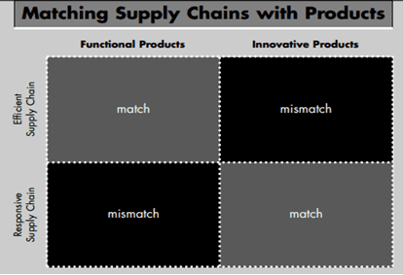

Figure 20: Fishers model used currently.

### 6.2 CURRENT SUPPLY CHAIN MODEL

The model currently followed by the company is a make to order (MTO) method. The phrase "make to order" describes companies that produce goods and services that are customised to a particular specification but not in a predictable way. (Saniuk and Waszkowski, 2016). As the consumer may customise their purchase, this system might be considered a responsive supply chain. Figure 21 shows the supply chain model that the company currently follows. The company manufactures its products with the past demand distribution data and currently operates a lean supply chain.

Figure 21: Current supply chain model

After applying the fishers model, we can analyse that the company's production of goods is functional and innovating falling in the responsive supply chain matrix of the fishers grid due to the current MTO business model.

# 7. OPERATIONS MANAGEMENT

A product portfolio has been expanded for the client company, as well as colour options have also been diversified. In order to grow the company's revenue and expand its customer base, these steps were taken by the company. To fulfill consumer demand, a supply chain strategy can be developed by applying Fisher's (1997) explanations of the supply chain features.

### 7.1 MARKETING

Using the given data set the yearly demand distribution for the product family bins and planters has been illustrated below

Figure 22: Typical demand performance through the years

Figure 22 illustrates that demand for planters escalates from January to May, which is essentially the spring season a period ideal for gardening. while the demand stabilises over summer and is seen declining as autumn and winter approaches owing to a lack of sunlight and increased humidity. The graph demonstrates that the demand for planters’ peaks in February and April, accounting for the majority of the company's annual revenues. Similarly, the focus on demand is highest in April and May, which account for one-third of the company's annual revenues. When it comes to bins, we notice that demand is almost the polar opposite of planter demand throughout the year. Sales appear to grow in January and February, a decline in the spring (March-May) and summer seasons (June- August), and then increase again in the autumn (September – October), demonstrating that the corporation can produce throughout the year and handle different product families as demand varies. This also demonstrates that the business would not have an off-season with several items.

### 7.2 SUPPLY CHAIN

The company presently functions on a lean supply chain because they produce functional goods with past demand distribution as shown in figure 11.

|  |  |
| --- | --- |
| MATCH  CURRENT POSITION | MISMATCH |
| MISMATCH | MATCH |

INNOVATIVE PRODUCTS

FUNCTIONAL PRODUCTS

EFFICIENT SUPPLY CHAIN

RESPONSIVE SUPPLY CHAIN

Figure23: current fishers’ model of the company.

With three different product families today, the company should split their supply chain operations and implement a hybrid production strategy to achieve a more agile approach to its Operations management. Figure below is the suggested fishers model recommended to the company (figure 24), more elaborately explained after figure 25 and 26.

|  |  |
| --- | --- |
| MATCH  BINS  PLANTERWARE | MISMATCH |
| MISMATCH | SELF-WATERING  MATCH |

INNOVATIVE PRODUCTS

FUNCTIONAL PRODUCTS

EFFICIENT SUPPLY CHAIN

RESPONSIVE SUPPLY CHAIN

Figure 24: Suggested fishers model using both MTO and MTS

Figure 25 shows the current production process of the company, which uses the make-to-order method where the order penetration point comes in before the product is moulded.  The company should change their production process by implementing MTS (made to stock) for a few products and a hybrid of MTO and MTS for a few by analysing data using the demand performance graph.

Figure 25: Current MTO supply chain method

As shown in figure 22, both bins and planter-ware have a seasonal demand distribution. Bins are in greatest demand when sales of planter-ware are declining. According to figure 22 , this demand distribution and seasonal analysis helps to bring together the supply chain, marketing, and sales functions of the company. Keeping in mind that seasonal demand and the demand generated after marketing are balanced and met with production needs. The company should stick to a Made-to-Stock production system for bins and planter-ware in order to maintain the lean supply chain. This will also decrease the possibility of the bullwhip effect when there is a fluctuation in the demand for the products avoiding hoarding excess stock and wastage. If the company follows a made to stock production method, the Order penetration point would be between quality inspection and packaging.

Figure 26: Company's Supply chain model with the OPP for MTS method for Planter ware and Bins

As for the Self-watering line, which has a variety of products and colours available, the company can implement a hybrid method of production using lean and agile where lean supply means the supply chain has minimal inventory buffering since task time is set so every stage functions at the same time with frequent deliveries and agile in a volatile market, one has to use market knowledge and to create a responsive supply network. (Nailor et all.,1999). Therefore, the production team can separate the production into lean and agile at the point of decoupling. In contrast, self-watering planters are made out of the same material before being differentiated into colours therefore a lean supply method can be followed. A MTS method would rather set a production goal than set a production goal with the intention of trying to sell the product, instead estimating how many orders the intended product might generate and then providing enough stock to satisfy those orders (Investopedia, 2022).This system allows the company to produce products in a make to stock production system, and then at the decoupling point, it can separate the products into different colours using a make to order method by using the agile supply method. Following this method can also help the company to improve its due date performance by delivering orders on time. If sales of self-watering keep on increasing the way it has since 2010 as shown in figure 4, the implementation of a hybrid of MTO and MTS in the companies production process. An existing example that uses the hybrid supply method is Zara.

Figure 27: Lean/ agile supply chain method

# 8. CONCLUSION AND RECCOMENDATIONS

To achieve competitive advantage and surpass client expectations, an organization's capabilities must now be organized so that they enhance one another's attributes, thus cooperating to develop a business proposal that proves to be unparalleled to its competitors and is far beyond the expectations of clients. After reviewing all of the findings and analysis provided above, the following recommendations were made for the client company.

* Separate manufacturing processes are recommended to assist the customer preserve comparative edge and successfully fulfil increased orders. The company should consider implementing a made to stock supply chain method for bins and planter-ware (refer to figure 22) as they are functional products that are available for sale. Applying the MTS method to the supply of bins and planters could help avoid a bullwhip effect to occur if there is any fluctuation in the demand of either product category.
* On the other hand, the innovative products that are available are the self-watering planters. For these products it is recommended that the company applies a hybrid of make to order and make to stock (refer to figure 24). As the firm offers a variation of 14 different colours made from the same material, they could increase their due date performance as, sales and save wastage of material by producing the self-watering planters till the quality inspection step/decoupling point. After which the firm could implement a made to stock method and produce as per customer specialization directly proportionally improving the delivery efficiency. If the firm have had stuck to the make to order method for self-watering planters keeping in mind the number of colours the product has to offer in the product line would fall into the mis-match quadrant in the fisher’s model leading it to not satisfy customer needs during production till delivery.
* For the firm to upkeep to the forecasted predictions and the rise in sales of its products of self watering platers , it is recommended that the company focus on marketing and selling of pink granite, guerney granite, and brown as they were sold and preferred the most.
* As the introduction of different colours and size of self-watering planters seems to have helped and made a positive impact on the sales of the company. They should consider introducing more options for their other products as well , namely bins and planters to increase sales and performance.
* When the typical demand performance for the year was calculated (figure 22) showing the best strategy to be implemented for bins and planters. Being an MTS and hybrid method. Implementing these methods in the future could really help the company gain financially. The graph shows a polar opposite of the peaks and decline of each product proving the firm can strategically plan their inventory and stock production respectively. By following the seasonality of the product ranges, you can determine the stock levels required of the products and adjust them accordingly.
* When individual products are considered the company should look into fully discontinuing J-C41, J-C45- T3, J-C45-T4 and J-EPS40-DG. All these products are non-terracotta colours and have not made any sales since 2010.
* Another recommendation would be for the company to generate accurate information for each month going forward in order to be able to determine whether the pattern has changed or not with the hope of alleviating as much stress as possible for the company.
* Lastly by introducing new production methods the firm could benefit by focusing on particular products at peak sales time and implement different marketing strategies to improve productivity and sales.

# 9 .REFERENCES:

Emese Felvegi, Brown, N., Lave, B., Romey, J., Schatz, M., Shingledecker, D. and McCarn, R. (2019). *10.1 Cleaning And Restructuring Data In Excel*. [online] Pressbooks.pub. Available at: https://uhlibraries.pressbooks.pub/mis3300excel/chapter/10-1-cleaning-data/ [Accessed 12 May 2022].

Intaher M. Ambe (2011). Framework for choosing supply chain strategies. *AFRICAN JOURNAL OF BUSINESS MANAGEMENT*, 5(35). doi:10.5897/ajbmx11.016.

Investopedia. (2022). *Understanding Make To Stock (MTS), Drawbacks, and Alternatives*. [online] Available at: https://www.investopedia.com/terms/m/make-to-stock.asp [Accessed 20 May 2022].

Kamble, A. and Deshmukh, R. (2022). *Flower Pots & Planters Market Size & Share | Research Report 2027*. [online] Allied Market Research. Available at: https://www.alliedmarketresearch.com/flower-pots-and-planters-market-A06448.

Persistence Market Research. (2022). *Gardening Tools Market*. [online] Available at: https://www.persistencemarketresearch.com/market-research/gardening-tools-market.asp [Accessed 12 May 2022].

Saniuk, A. and Waszkowski, R. (2016). *Make-to-order manufacturing - new approach to management of manufacturing processes*. [online] ResearchGate. Available at: https://www.researchgate.net/publication/307875995_Make-to-order_manufacturing_-_new_approach_to_management_of_manufacturing_processes [Accessed 18 May 2022].

The (2020). *Self-watering Planters and Pots Market 2028 By Material Type, Distribution Channel and Geography | The Insight Partners*. [online] The Insight Partners. Available at: https://www.theinsightpartners.com/reports/self-watering-planters-and-pots-market [Accessed 11 May 2022].

Wikipedia Contributors (2022). *Predictive analytics*. [online] Wikipedia. Available at: https://en.wikipedia.org/wiki/Predictive_analytics [Accessed 18 May 2022].

# 10. APPENDIX:

APPENDIX 1: Count of product sold

|  |  |
| --- | --- |
| **Row Labels** | **Count of Product** |
| Bins | 20 |
| Planterware | 37 |
| Self-Watering | 145 |

APPENDIX 2: Sales by product family

|  |  |  |  |  |
| --- | --- | --- | --- | --- |
| **YEAR** | **BINS** | **PLANTERWARE** | **SELF-WATERING** | **GRANDTOTAL** |
| 2006 | 214400 | 0 | 1254936 | 1469336 |
| 2007 | 204395 | 0 | 1397084 | 1601479 |
| 2008 | 220299 | 0 | 1327442 | 1547741 |
| 2009 | 141386 | 0 | 1183648 | 1325034 |
| 2010 | 590825 | 44702 | 1268483 | 1904010 |
| 2011 | 389870 | 137654 | 1398217 | 1925741 |
| 2012 | 399145 | 251217 | 1683063 | 2333425 |

APPENDIX 3: NO. OF UNITS SOLD PER PRODUCT FAMILY

|  |  |  |  |  |
| --- | --- | --- | --- | --- |
| **Values** | **Bins** | **Planterware** | **Self-Watering** | **Grand Total** |
| 2006 | 1230 |  | 22892 | 24122 |
| 2007 | 1453 |  | 24438 | 25891 |
| 2008 | 1674 | 0 | 23135 | 24809 |
| 2009 | 1328 | 0 | 21898 | 23226 |
| 2010 | 2543 | 809 | 19118 | 22470 |
| 2011 | 2081 | 2426 | 20336 | 24843 |
| 2012 | 2048 | 4464 | 23429 | 29941 |

APPENDIX 4: TOTAL PROFIT EARNED B

|  |  |
| --- | --- |
| **PRRODUCT** | **TOTAL PROFIT** |
| Bins | 1481527.2 |
| Planter-ware | 178445.5 |
| Self-Watering | 6065797.2 |

APPENDIX 5: SALE OF SELF WATERING PRODUCTS BY COLOUR

|  |  |  |  |
| --- | --- | --- | --- |
| **year** | **standard colour** | **special colour** | **total sales** |
| 2006 | 1254936 | 0 | 1254936 |
| 2007 | 1397084 | 0 | 1397084 |
| 2008 | 1327442 | 0 | 1327442 |
| 2009 | 1183648 | 0 | 1183648 |
| 2010 | 1268483 | 0 | 1268483 |
| 2011 | 1278925 | 119292 | 1398217 |
| 2012 | 1495766 | 187297 | 1683063 |

APPENDIX 6: TOTAL SALES OF SELF – WATERING PLANTERS DURING 2006-2012

|  |  |
| --- | --- |
| **Description** | **Total sales unit** |
| Wall and window box | 3376 |
| Up the pole basket | 1126 |
| Terresterial Basket | 2083 |
| Octagonal fountain (3) | 25 |
| Octagonal fountain (2) | 4 |
| Octagonal fountain (1) | 71 |
| Octagonal fountain | 2362 |
| Meter sq planter (4) | 30 |
| Meter sq planter (3) | 1064 |
| Meter sq planter (2) | 85 |
| Meter sq planter (1) | 61 |
| Meter sq planter | 1392 |
| Half pole basket | 9038 |
| half cup and saucer up the pole | 2766 |
| Half basket up the pole | 28947 |
| Half barrier basket liner | 296 |
| Half barrier basket | 5450 |
| Full barrier basket | 1279 |
| Floural fountain | 921 |
| Floor standing oval planter | 303 |
| Cup and Saucer on pole | 25573 |
| Cup and Saucer (HB) | 11774 |
| Cup and Saucer | 9330 |
| Cup and Saucer | 16553 |
| Conventional Hanging Basket | 6882 |
| Bee hive fountain (6) | 937 |
| Bee hive fountain (5) | 730 |
| Barrier Basket Liner | 12207 |
| Barrier Basket | 9528 |
| Barrel | 1053 |

APPENDIX 7: TOTAL SALES OF BINS

|  |  |
| --- | --- |
| **Description** | **sales (units)** |
| Olympic dual bin | 1916 |
| Ample bin | 785 |
| Stipple bin | 1251 |
| West min bin | 2823 |
| Penguin bin | 821 |
| Square hood bin | 70 |
| West min liner | 1858 |
| Tapered hood bin | 240 |
| Robin bin | 81 |
| Enviro can recycle – post | 517 |
| Eco bin | 335 |
| Parot bin | 84 |
| Bear bin | 116 |
| Screwball post bin | 162 |
| Slim bin | 395 |
| Chick bin | 141 |
| Westmin recycle | 193 |
| Eviro bin – floor | 536 |
| Poo bin | 10 |
| Screwball post bin | 23 |

APPENDIX 8: TOTAL SALES OF BINS 2006-2012

|  |  |
| --- | --- |
| **Column1** | **Column2** |
| Ample bin | 117750 |
| Bear bin | 34800 |
| Chick bin | 35250 |
| Eco bin | 67000 |
| Enviro can recycle – post | 64625 |
| Eviro bin – floor | 150080 |
| Olympic dual bin | 862200 |
| Parot bin | 23520 |
| Penguin bin | 205250 |
| Poo bin | 1200 |
| Robin bin | 20250 |
| Screwball post bin | 23360 |
| Slim bin | 39105 |
| Square hood bin | 12600 |
| Stipple bin | 68805 |
| Tapered hood bin | 72000 |
| West min bin | 211725 |
| West min liner | 92900 |
| Westmin recycle | 57900 |

APPENDIX 9: TOTAL UNITS OF SALES OF PLANTERWARE 2006 - 2012

|  |  |
| --- | --- |
| **Description** | **total sales(unit)** |
| Plain vase | 2591 |
| Rectangular container | 1500 |
| Egg pot vase | 1022 |
| Egg pot square | 737 |
| Tall square | 692 |
| Square | 619 |
| Cylinder | 298 |
| Tall vase | 152 |
| Window Box | 57 |
| Garlanded vase | 31 |
|  |  |

APPENDIX 10: TOTAL SALES OF PLANETR WARE 2006-2012

|  |  |
| --- | --- |
| **Description** | **Sales (pounds)** |
| Plain vase | 129785 |
| Rectangular container | 87426 |
| Egg pot vase | 68912 |
| Egg pot square | 55280 |
| Tall square | 33572 |
| Square | 27660 |
| Cylinder | 13185 |
| Tall vase | 11546 |
| Window Box | 3648 |
| Garlanded vase | 2559 |

APPENDIX 11: SALES 2006-2012

|  |  |
| --- | --- |
| **Years** | **total sales (units)** |
| 2006 | 24122 |
| 2007 | 25891 |
| 2008 | 24809 |
| 2009 | 23226 |
| 2010 | 22470 |
| 2011 | 24843 |
| 2012 | 29941 |

APPENDIX 12: TYPICAL DEMAND PERFORMANCE

|  |  |  |
| --- | --- | --- |
| **MONTHS** | **Planters** | **Bins** |
| Jan | 3 | 10 |
| Feb | 8 | 11 |
| Mac | 13 | 8 |
| April | 18 | 4 |
| May | 18 | 2 |
| June | 15 | 3 |
| July | 10 | 7 |
| August | 8 | 7 |
| Sept | 3 | 8 |
| Oct | 2 | 13 |
| Nov | 1 | 15 |
| Dec | 1 | 12 |